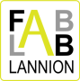
Fablab Lannion

Fablab Lannion will celebrate its 4th birthday end of 2016.
The association is now a well known actor of local innovation on the territory by local, regional and international actors (see press review, see mention in Liberation's article ).

The association is hosted in a Technical French Lycée and has already a good park of machines (several 3D printer, a Laser cutter, several milling machines. The number of members is about 100 and the number of people registered on our web site is greater than 500.

The Fablab successfully participated to Data+ challenge, a challenge organized by Orange and Rennes metropole to design and create an object able to make data real. The association also create a DIY kart for the makerrr race in 2015.

Libre en fête en Trégor (http://libre-en-fete-tregor.fr/), one of the major event on free software (more than 800 participants, 90 volunteers, 20 associations, academics, startups) took place in March 2016 and was mainly organized by the fablab (in charge of the budget, Fablab, Gaming, Multimedia and Citizen spaces).

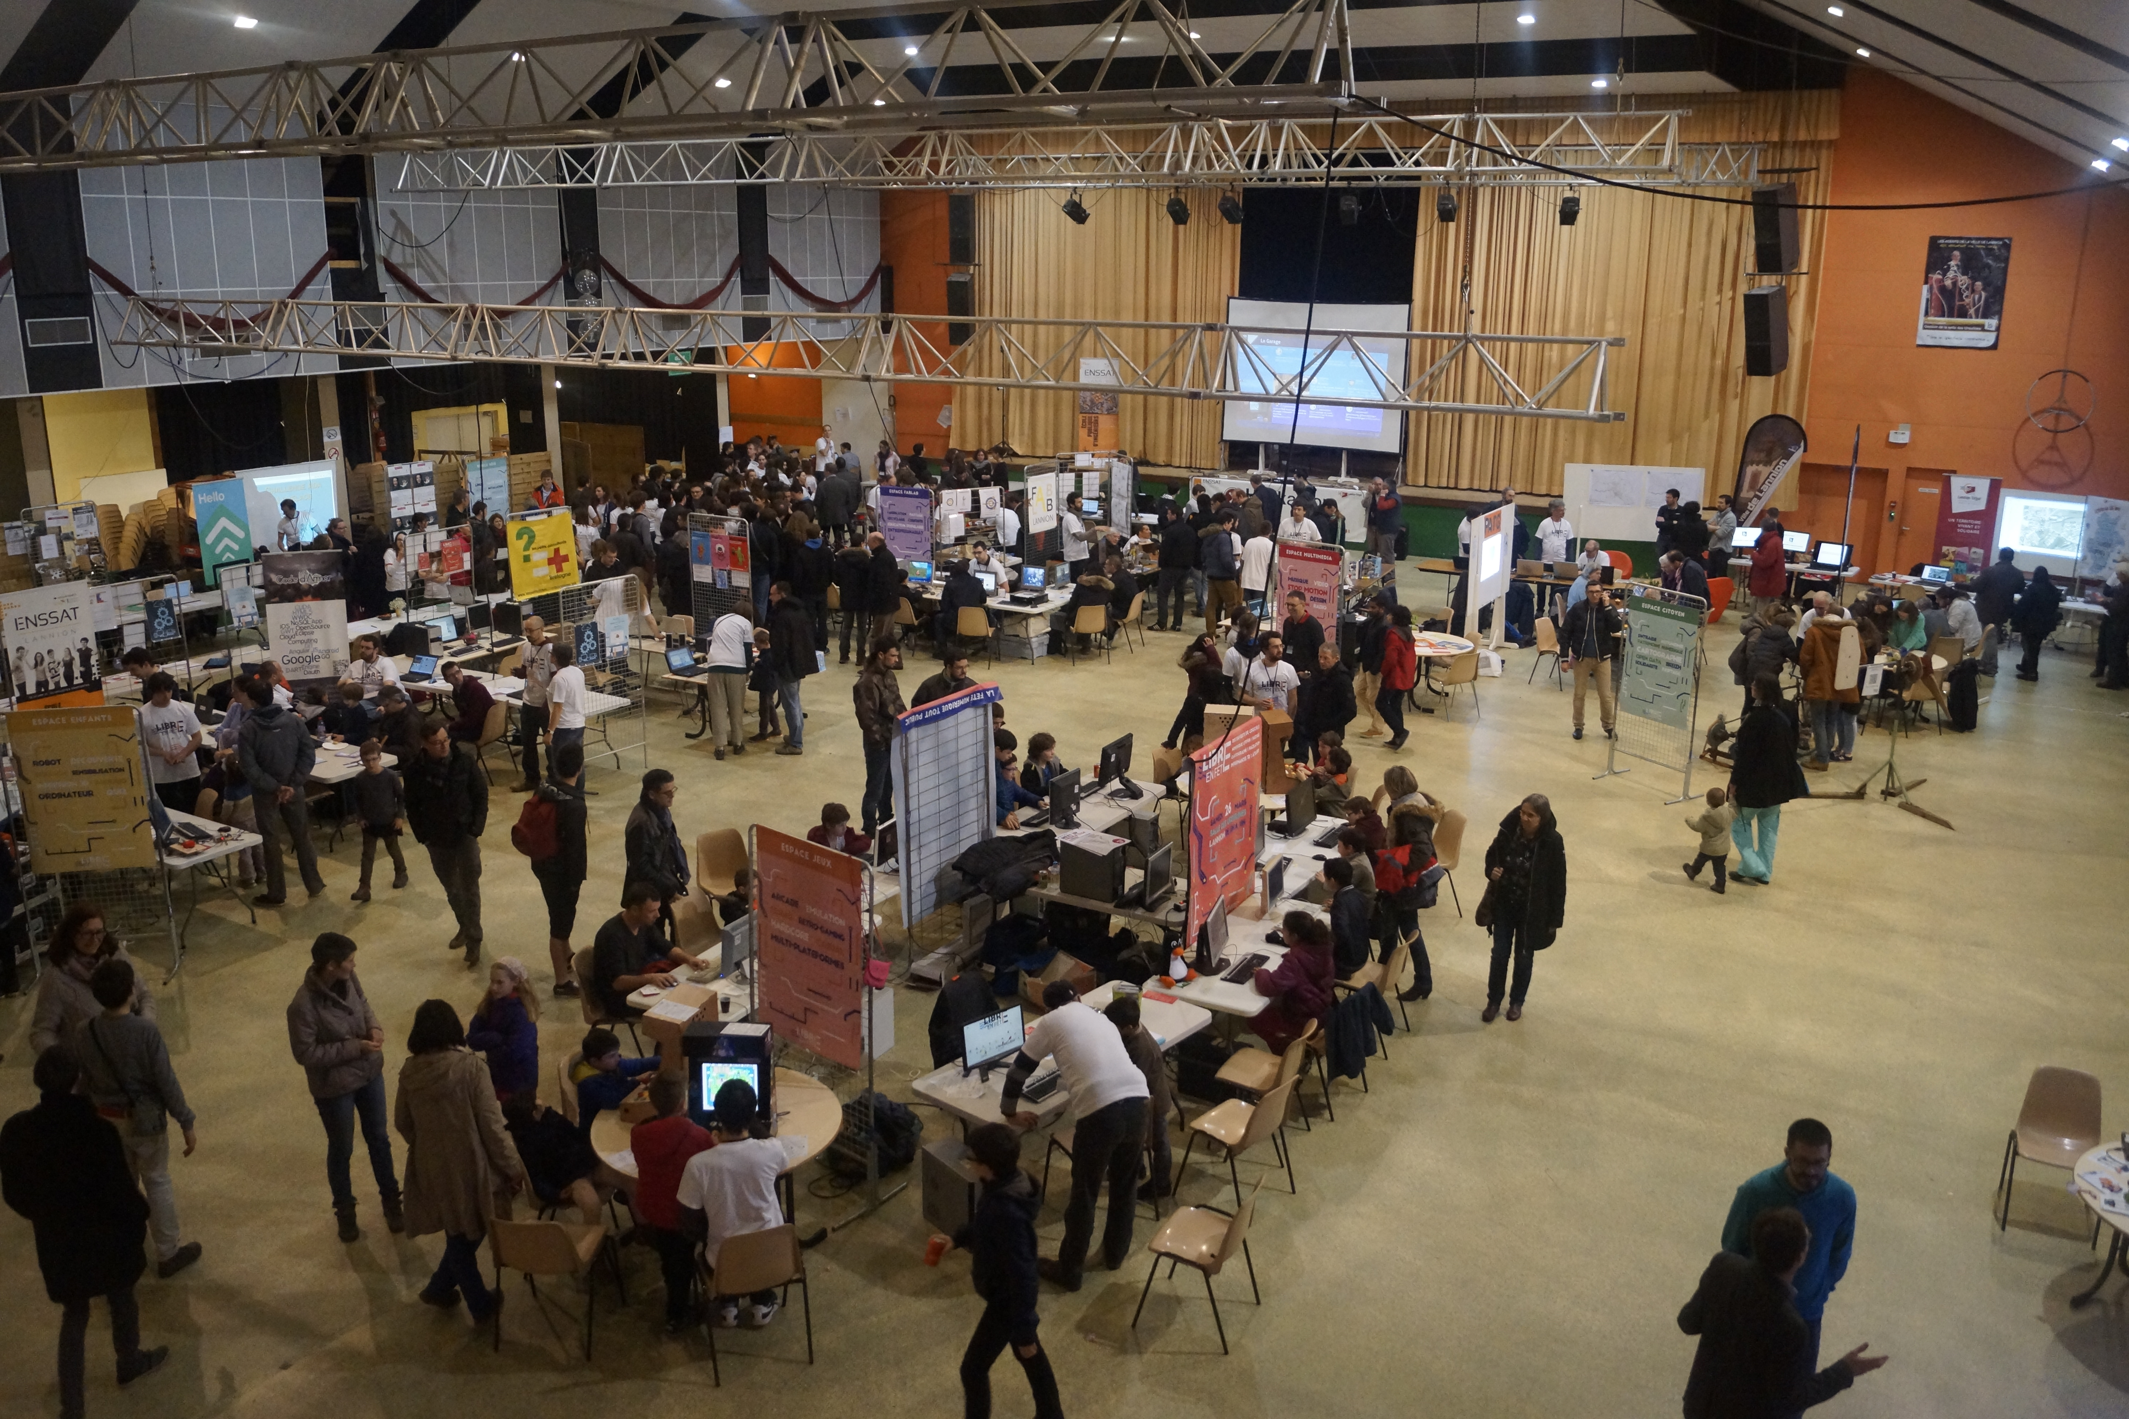

Fablab Lannion also contributed to the elaboration of a MooC on digital education for FUN (France université numérique), and more precisely on the chapter on connected objects..
In 2016, the association set up a Fablab Junior design programm aiming to explain to young people how to use the main machines of a fablab (laser cutter, 3D printing, arduino, ..).
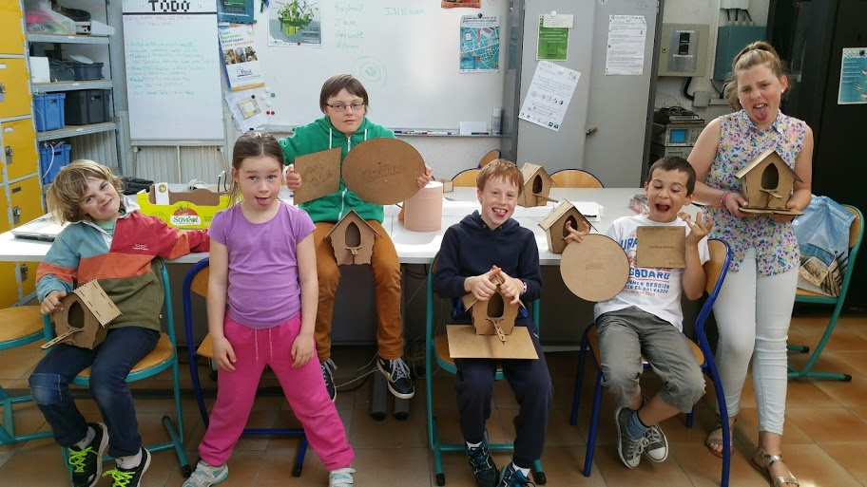

Our association is also in charge of the organization of « les Adonnantes », a event to promote innovation open to everyone including students in order to mix innovators and start up creators, the goal is to federate synergies on the territory

One Fablab, several missions

The Fablab status detail all the missions of the association.
These missions are multiple but are in line with MIT charter especially regarding popular education in order to easy knowledge sharing and stimulate innovation.
The business development is also an important aspect of the fablab. Founder of the adonnants, the association signed a partnership for the local agency for business development (Anticipa). First attempts have been done in 2015 and confirmed that the Lannion ecosystem is well adapted for this mission.

The association has other partnerships. We host the co-working activity of our city and we work with « Les petits débrouillards », an association dealing with science for young public.



